PERSONAL INFORMATION
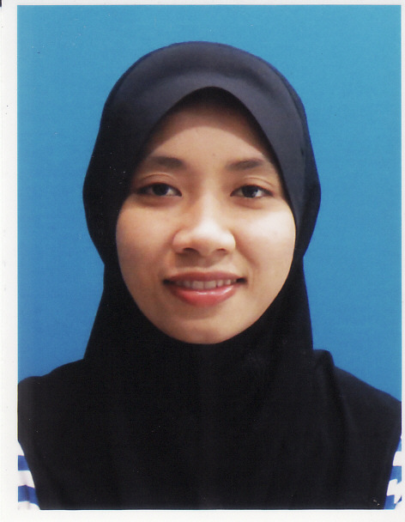
Name: Nurshuhadah binti Md Ahir
Permanent address: Batu 46 ¾, Kampung Sik Dalam,
08200 Sik, Kedah. Malaysia.
Current address: No. 6, Simpang 123, Kampung Burung Pingai,
Berakas, BB3313, Negara Brunei Darussalam.
Contact Number: +6017-4032991, +673-8302818
E-mail: nur_shuhadah@hotmail.com
Date of Birth: 4 December 1985.
Marital Status: Single.

EDUCATION
2008 – 2011 UNIVERSITI KUALA LUMPUR (INSTITUTE PRODUCT DESIGN AND MANUFACTURING)
Bachelor of Engineering (Hons.) in Product Design.

2005 – 2007 GERMAN MALAYSIAN INSTITUTE
Diploma in Production Technology (Mould Technology).

2003 – 2004 INSTITUT KEMAHIRAN MARA LUMUT
Certificate Mechanical Engineering (Draught and Design).

CAREER OBJECTIVE
- Seeking for position as an engineer with opportunities to enhance both technical and management skills.
- To become a professional engineer with the skills required and have the ability to work with anyone in any condition.
- To get more work experiences, skills and knowledge and achieve its respective goals.

PERSONAL STRENGTH
I have been describing as I am discipline and responsibility person. I am highly inquisitive, willing to learn and accept any consequences from my action. I also creative, resourceful and fast-learner and I can work independently as well as work in team. Willing to move and can start from any level position.

WORKING EXPIRENCE
- Emstech Engineering Sdn. Bhd.(January 2007 – March 2007)

Scope of work

- Maintenance mould, run injection mould machine, packing product, labeling product name.

- Proeight Offshore Engineering Sdn. Bhd. (December 2009 – May 2010)

Scope of work

- Controlling documentation with other department (Purchasing, store, QA/QC and engineering).
- To ensure each department get the correct document.

- Promoter Baby Kiko.
Scope of work
- To responsible for sales performance of assigned outlets.
- To maintain and up- keep KIKO counters to ensure cleanliness and good product display
- To conduct 100% stock check by end of every month to ensure quantity of stock are as accurate as possible.
- To ensure safe keeping of KIKO product at counter in order to reduce the pilferage rate/ stock loses.
- To cultivate good customer relationship in order to project a positive image of the company.
- To be able to identify fast moving category of KIKO’s products and revert to company on requirement of stock.

- Trans Resources (B) Sdn. Bhd. (TRC) (July 2012 – March 2016)
Position: M&E Assistant Engineer.
Project involved: Modernization of Brunei International Airport.
Client: Brunei Economic Development Board (BEDB)
Project contract: B$ 130,000,000.00

Scope of work

- To do submission shop drawing for consultant approval, then submit the approval shop drawing to sub-contractors.
- To do site coordination with sub-contractors and site detailing issues.
- To do summary for M&E outgoing drawing for endorsement submission.
- To prepare as built drawing Mechanical and Electrical for external and internal building for final submission.
- Liaise with consultant in any drawing issue and submission to client.
- Liaise with sub-contractor in any drawing issue and submission for approval.
- Attending monthly site meeting with client, consultant & sub-contractor.
- Assist M&E Coordinator in any Mechanical and Electrical works.

- HSE Engineering Sdn Bhd (April 2016 – Current)
Position: M&E Draft person.
Project involved: The Brunei Cancer Centre (TBCC) & Brunei neuroscience, Stroke and Rehabilitation Centre (BNSRC).
Client: Brunei Investment Arm (BIA)
Project contract: BND 199,000,000.00

Scope of work

- To do submission shop drawing for main contractor review and approval.
- Liaise with main contractor in any drawing issue and submission for approval.
- To do site coordination with relevant sub-contractors and site detailing issues.
- To prepare as built drawing Mechanical and Electrical for external and internal building for final submission.

COMPUTER SKILL

AutoCAD, Master cam. CATIA, Microsoft Office, Microsoft project, CAD 3D Modeling, Solid work, Ideal 8, CNC milling & programming, CAD CAM 2 & 3 Axis EDM Die-sinking & Wirecut.

LANGUAGE
Spoken language: Malay and English.
Written language: Malay and English.

REFERENCES
Managing Director of HSE Engineering Sdn. Bhd.
Mr. Michael Chang Chai Woon
HSE Engineering Sdn. Bhd.
Unit 1, 2nd Floor, Block D, Kiarong Complex, Bandar Seri Begawan, BE 1318, Brunei Darussalam.
Tel: +673 2443544/5
Mechanical and Electrical Coordinator of TRC (B) Sdn. Bhd.
Mr. Albert Tiong
TRC (B) Sdn. Bhd.
Unit 36, 1st floor, Haji Munchit & Dayang Rapiah Complex, Simpang 13, Kampung Jaya Setia,
Jalan Berakas, Bandar Seri Begawan BB 2713, Brunei Darussalam.
Tel: +673 233 8986

EXPEXTED SALARY: RM 3,500.00 (negotiate).

